# **Project Yasee Manual**

Overview:

This document serves as a manual for using Yasee as well as future development and extension of the codebase. Main functionalities of Yasee will be introduced with image to illustrate the process, while limitations of Yasee will be described with explanation of what caused such limitations and what potential future direction the project can take. There will also be a brief walkthrough of the codebase structure to demonstrate its implementation using the Python environment and its various libraries.

Introduction to the User Interface:

A primitive console user interface is implemented. You may click on main.py in the project’s top directory to launch our program. Due to time and manpower limitations, the proposed graphic user interface / web app interface was not implemented. There are three options in the main menu of our software, each representing a specific category of analysis. Input a), b), c) or q) in the console to issue the corresponding command prompts.



Fig. 1. Main Console View

**Word Cloud Visualization**

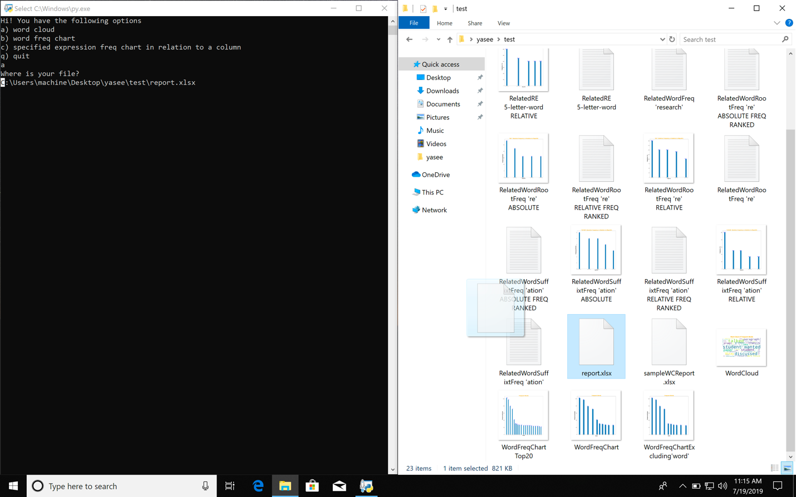

Fig. 2. Drag and Drop

The Word Cloud Visualization gives you an intuitive “feel” about your textual data by visualizing word frequency in a single image of words forming a text cloud. To perform the visualization, you have to tell the program where your Excel file (which contains textual data of your research interest) is. You can simply drag and drop your excel file into the console window as illustrated above. After you drop the file, the path of the file should be shown under “Where is your file?”, as seen above (C:\Users\ma…).

The next step would be choosing your “stop words”, as illustrated in the picture below (see Fig. 3.)

Stop Words

* Stop words are words that carry no meaning in your specific search query. For example, words like “are”, “is” or “the” rarely matters if you want to visualize word frequency. Stop words will be purposefully skipped when the program performs an analysis of word frequency. However, stop words are not factored when performing category c) analysis.
* There are two files in our project that specify default stop words. They are: UCIWC_DEFAULTSTOPWORDS.py and YaseeStopWords.py, which respectively contains default stop words for UC Irvine Writing Center and for a broader audience of a general researcher. The reason of implementing two separate stop word modules is that it provides layers of abstraction in project structure so future extensions can be made. As of now, we recommend that you modify the UCIWC_DEFAULTSTOPWORDS.py file to add stop words. However, modifications of both files will have the same effect.



Fig. 3. Adding stop words

If you are only interested in adding stop words, you can also do so via the console window by inputting all stop words separated by spaces. You may now answer the follow-up questions (as seen in Fig. 4) that shows after the program successfully locates your Excel file. If the program crashes, it means that it failed to locate and access the Excel file. The Excel file cannot be password-protected.

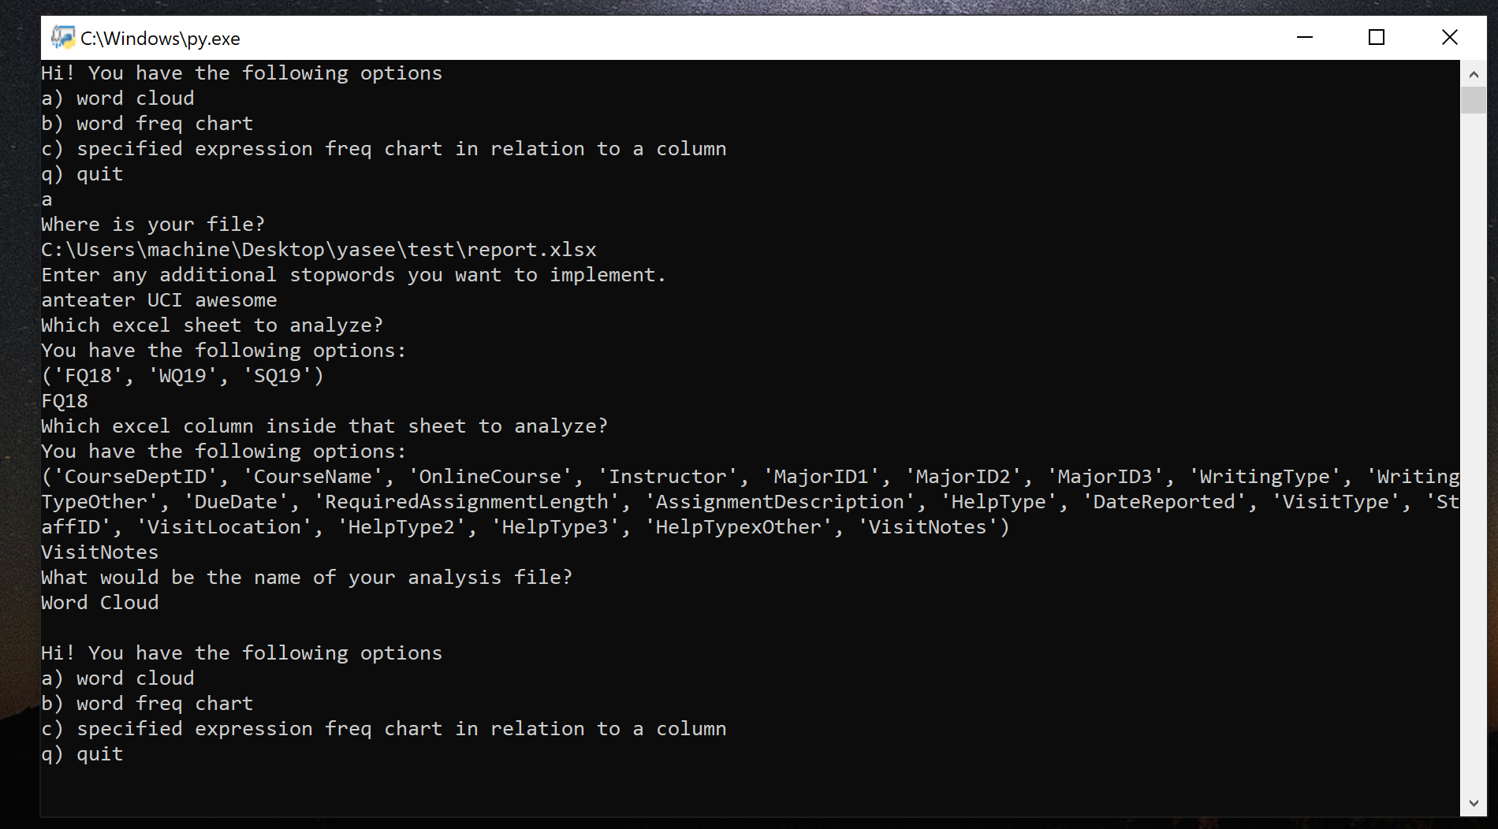

Fig. 4. Issue instructions answering the follow-up questions.

When you see the main menu option again, the word cloud visualization has been successfully performed. You can now see the image generated by the program in the directory you specified when you input the name of the analysis file. If you only specified the name but not the path of the analysis file, you can locate your file at your current directory along with the Yasee main.py.

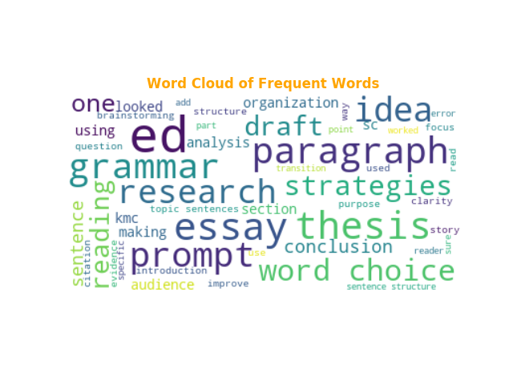

Fig. 5. A sample word cloud generated by Yasee

**Word Frequency Bar Chart Visualization**

By following steps similar to generating a word cloud, you may choose b) in the main menu of Yasee to generate a bar chart visualization of word frequency.

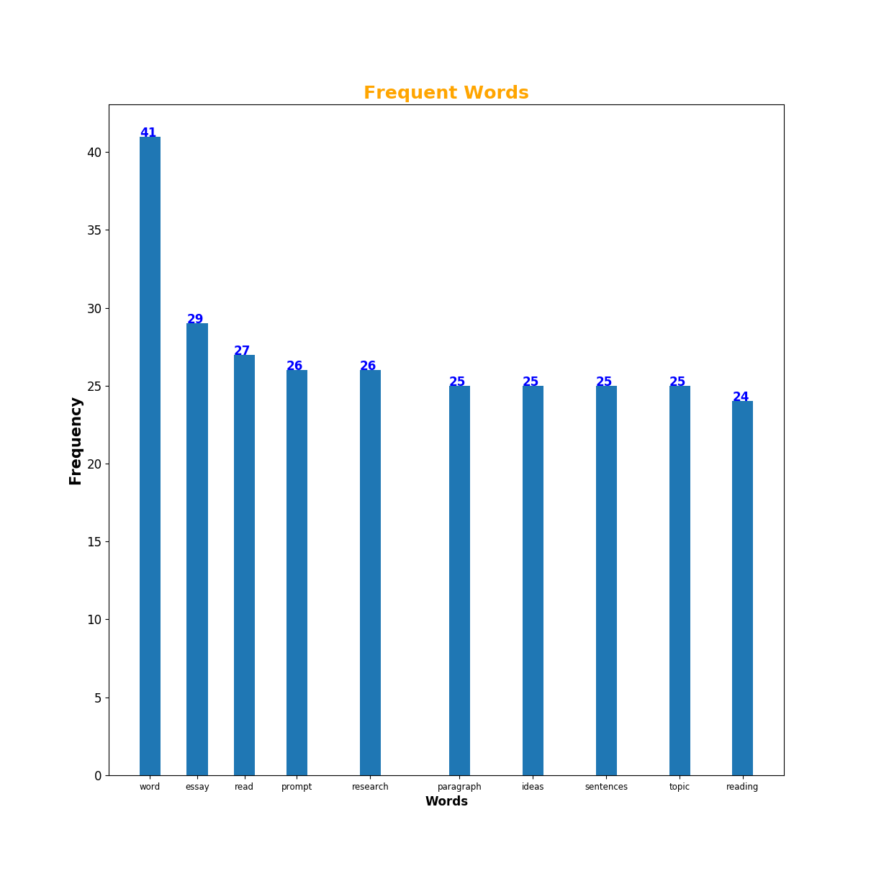

Fig. 6. A sample word frequency bar chart visualization by Yasee

As you can see in Fig.6, words are ranked by their frequency from highest to lowest, showing only the top X results that you get to specify in the follow-up questions after you choose b) in the program main menu. You may notice that the figure indicating the exact frequency number is shown above the bars, and the spacings of the bars are adjusted nicely so that the words at the bottom will never overlap with each other.

**Specified Expression Analysis**

This is where Yasee really “shines”. This module of functionality can visualize as well as provide context of textual data that helps researchers with textual data find a starting direction for their research. You may issue c) in the main program menu to perform this analysis.



Fig. 7. Specified Expression Analysis

You will be asked to first specify one column of interest in the Excel form you provided. This column is the one that contains textual data of interest. After specifying the column, you can now input your “specified expression”.

Specified Expression

* The expression can be as simple as a single word like “research” or “Irvine”. (Capitalization is ignored during the search process. “ReSEarch” and “research” will be treated the same)
* You can also input special expressions like pre* or *ation, which will prompt the program to search for words that begin with “pre”, and words that end with “ation”, respectively.
* Even cooler, our program can search for “regular expressions”. You need to begin your expression with “regex:”. For example, “regex:^(\w){5}$” will yield search results of words with exactly 5 English letters, like “mouse” or “place”.

After you input the specified expression, the program will automatically calculate “mutual information scores” across every other column and show them in the command window.



Fig. 8. Mutual Information Scores calculated across columns

Mutual Information Score

The mutual information (MI) of two random variables is a measure of the mutual dependence between the two variables. *

Generally speaking, the MI scores show connection between “ambiguous data” like textual data. It is used in our context for this very reason, since many other correlation metrics would require strictly numerical data. The goal of Yasee is not to provide a tool to perform statistical inference with scientific rigor, we have the R language and environment for that. In developing Yasee, we have in mind the goal to build a compact tool to find connections in data and bring them to the researchers’ attention, so that the researchers can examine them in depth and hopefully find directions for their research.

*: https://en.wikipedia.org/wiki/Mutual_information

You may now input the second column, which is chosen through the roaster list of columns ranked by their MI score in relation to your before-specified column. We suggest that you pick one from those with the highest MI scores, namely one column that shows great potential of correlation with the column containing textual data of interest. After you make this choice and answer the follow-up questions, the “specified expression analysis” should be successfully performed, with 5 files generated in the program main path (or any path that you may specify when you input the file name).



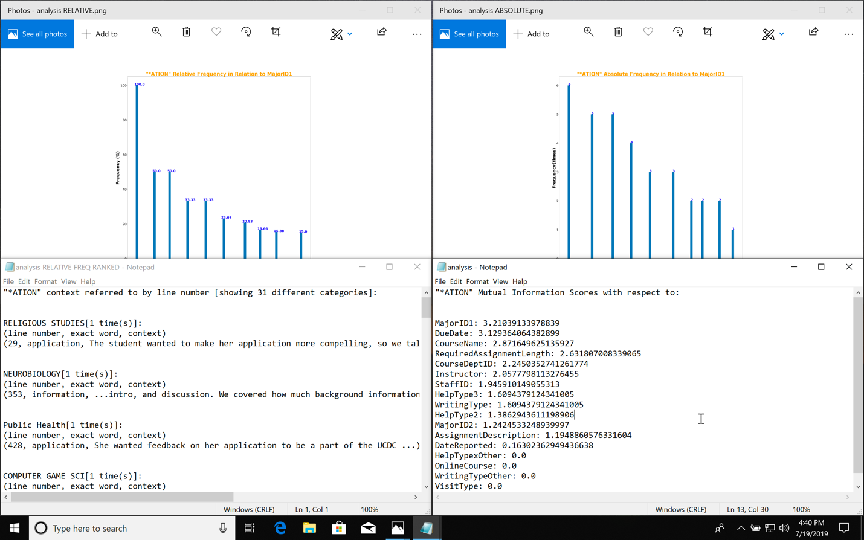

Fig. 9. The “analysis” files.

**Technical Structure and Code Style**

Yasee is written in pure Python, taking advantage of the existing data visualization community in Python. We used various data analysis libraries in our implementation, such as sklearn, pandas, matplotlib … To some extent, our program is mostly an application layer built upon these fantastic libraries built by brilliant programmers.

Our project is developed in a “test-driven” style. For each new module that we develop, we will write automatic tests for each newly developed functionality if possible. The end result is that our project now is more reliable for future developments and extensions.

Functional programming paradigm as well as meta programming is experimented in the development process (as indicated in the comments in the codebase).

**What does Yasee do and doesn’t?**

Yasee is a meta visualization/analysis tool to help researchers with textual data find a starting point for their research, tailored for consultation data provided by the Writing Center in University of California, Irvine. It is designed to only interact with textual data and provide suggestions for research directions. Yasee cannot substitute scientific statistical analysis because it is not supposed to pick that fight. The project is developed in a 5-week time window as a summer internship, which greatly limits the functionalities as well as the reliability of the program. There are bound to be some unknown bugs that are not foreseen. For example, the program still sometimes crashes when its I/O operation cannot be performed instead of handling these errors internally.

With all that said, we still believe that Yasee can help you at least find “interesting patterns” in a large sea of textual data, and that has always been the main goal of Yasee.